Case Study 1: University Scholarship Allocation
1. Problem Statement
Design a beginner-friendly system that evaluates a university applicant using aggregate marks, subject-wise minimum scores, attendance percentage, and annual family income criteria to determine scholarship eligibility.
2. Objectives
- Accept student details via standard input.
- Apply multiple conditional checks using logical operators (and, or).
- Display clear eligibility status messages.
3. Assumptions
- Aggregate marks are out of 100.
- Minimum subject score must be at least 50.
- Attendance must be at least 75%.
- Annual income must be less than or equal to $2,50,000$.
4. Algorithm
- Step 1: Start the program.
- Step 2: Read student name, aggregate marks, minimum subject mark, attendance percentage, and annual income.
- Step 3: Check if Aggregate Marks $≥80$, Minimum Subject Mark $≥50$, Attendance $≥75$, and Income $≤250000$.
- Step 4: If all conditions are true, print that the student is Eligible.
- Step 5: Otherwise, print that the student is Not Eligible.
- Step 6: Stop the program.

5. Flowchart (Textual Representation)
[Start]
--> [Read Student Inputs]
--> [Check Conditions: Marks >= 80, Min >= 50, Attendance >= 75, Income <= 250000]
--> {Are all conditions True?}
├── Yes --> [Print: Eligible for Scholarship] --> [Stop]
└── No --> [Print: Not Eligible for Scholarship] --> [Stop]

6.Pseudocode

START
PRINT "Enter Student Name:"
READ name
PRINT "Enter Aggregate Marks (out of 100):"
READ agg_marks
PRINT "Enter Lowest Subject Mark:"
READ min_mark
PRINT "Enter Attendance Percentage:"
READ attendance
PRINT "Enter Annual Family Income:"
READ income

IF agg_marks >= 80 AND min_mark >= 50 AND attendance >= 75 AND income <= 250000 THEN
PRINT name, "is ELIGIBLE for the scholarship."
ELSE
PRINT name, "is NOT ELIGIBLE for the scholarship."
ENDIF
STOP

7.Python Source Code

print("--- University Scholarship Evaluation System ---")
name = input("Enter student name: ")
agg_marks = float(input("Enter aggregate marks (0-100): "))
min_mark = float(input("Enter lowest mark in any subject: "))
attendance = float(input("Enter attendance percentage: "))
income = float(input("Enter annual family income (in INR): "))

if agg_marks >= 80 and min_mark >= 50 and attendance >= 75 and income <= 250000:
print("\nResult:", name, "is ELIGIBLE for the University Scholarship.")
else:
print("\nResult:", name, "is NOT ELIGIBLE for the University Scholarship.")
print("Reason: Did not meet one or more criteria (Marks >= 80, Min Mark >= 50, Attendance >= 75%, Income <= 2.5L).")

8. Test Cases
- Test Case 1 (Eligible): Name: Rahul, Marks: 85, Min Mark: 60, Attendance: 80, Income: 200000 $→$ Output: Eligible.
- Test Case 2 (Not Eligible - Low Attendance): Name: Priya, Marks: 90, Min Mark: 70, Attendance: 65, Income: 150000 $→$ Output: Not Eligible.

9. Output

--- University Scholarship Evaluation System ---

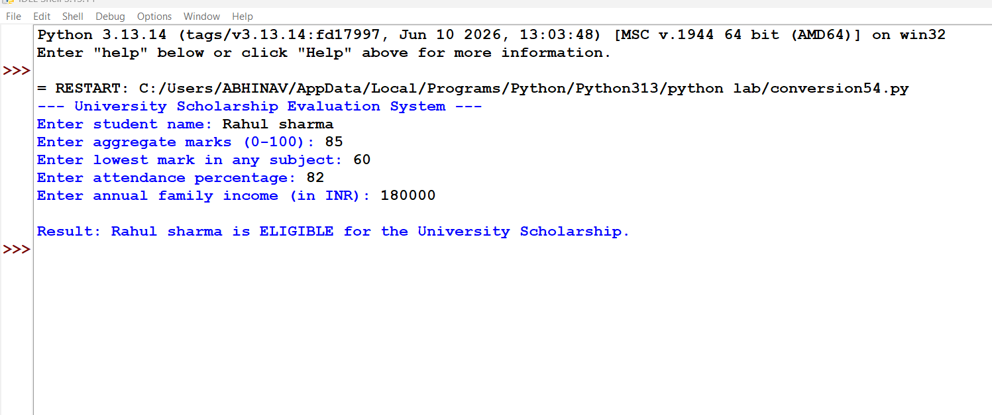

10. Conclusion

Successfully implemented a foundational Python script using basic conditional structures (if-elif-else) and logical operators to evaluate student data against multi-tier university eligibility policies.

